Github Link: <https://github.com/hariganesh200311/Predicting-customer-churn-using-machine-learning-to-uncover-hidden-patterns-.git>

**Project Title: Predicting customer churn using machine learning to**

**uncover hidden patterns**

**Student Name:** HARI GANESH.B

**Register Number:** 513523106302

**Institution:** AMCET

**Department:** ECE

**Date of Submission:** 5.5.2025

**Github Repository Link:** <https://github.com/hariganesh200311/Predicting-customer-churn-using-machine-learning-to-uncover-hidden-patterns-.git>

**1. Problem Statement**

*Businesses lose customers due to various reasons, such as dissatisfaction, competitive alternatives, or changing preferences. Identifying customers likely to churn before they leave can help companies take proactive measures to retain them, reducing revenue loss and improving customer satisfaction.*

*The objective of this project is to develop a machine learning model that predicts customer churn based on historical data. The model will analyze customer behavior, transactions, interactions, and engagement patterns to uncover hidden trends that signal potential churn.*

*Customer churn, the phenomenon where customers discontinue their relationship with a company, poses a significant challenge across various industries, especially in sectors such as telecommunications, finance, and subscription-based services. High churn rates can lead to substantial revenue loss and increased customer acquisition costs. The ability to accurately predict which customers are likely to leave allows companies to proactively take retention measures and improve customer satisfaction.*

*This project aims to develop a machine learning model that predicts customer churn by uncovering hidden patterns in historical customer data. By analyzing factors such as customer demographics, usage behavior, transaction history, and customer service interactions, the model will identify key indicators of churn. The goal is to equip businesses with a data-driven approach to customer retention, enabling timely interventions and more efficient allocation of marketing resources.*

**2. Abstract**

*This project aims to develop and deploy a predictive model leveraging machine learning algorithms to identify customers at high risk of churn. By analyzing historical customer data, including behavioral patterns, demographic information, and transactional history, the model uncovers complex relationships and key drivers of churn.*

***The project objectives include:***

*1. Data preprocessing and feature engineering*

*2. Model development and evaluation using various machine learning algorithms*

*3. Identification of key factors contributing to customer churn*

*4. Development of a predictive model for proactive retention strategies*

***The expected outcomes include:***

*1. Improved customer retention rates*

*2. Enhanced customer satisfaction*

*3. Reduced revenue loss due to churn*

*By delivering a data-driven approach to predicting customer churn, this project aims to provide businesses with actionable insights to inform retention strategies and improve customer relationships.*

*Extensive data preprocessing, including handling missing values, feature selection, normalization, and class balancing techniques like SMOTE, is applied to improve model performance and reliability. The models are trained and evaluated using stratified cross-validation to ensure generalizability. Performance metrics such as accuracy, precision, recall, F1-score, and ROC-AUC are used to assess and compare the effectiveness of each algorithm. Feature importance analysis is conducted to identify the most influential factors contributing to customer churn.*

*The results demonstrate that machine learning can effectively predict churn with high accuracy, enabling companies to act proactively. The final model can be integrated into business decision systems to trigger retention campaigns, optimize customer support, and prioritize high-risk customers for personalized engagement. This approach not only minimizes revenue loss but also strengthens customer loyalty and enhances overall business performance. The project illustrates the transformative potential of AI-driven insights in customer retention strategies.*

**3. System Requirements**

*Here are the system requirements for predicting customer churn using machine learning:*

***Hardware Requirements:***

***1. Processor:*** *Multi-core CPU (e.g., Intel Core i5 or i7)*

***2. Memory:*** *8 GB or more RAM*

***3. Storage:*** *256 GB or more SSD storage*

***Software Requirements:***

***1. Programming Language:*** *Python (with libraries like scikit-learn, pandas, NumPy)*

***2. Machine Learning Framework:*** *TensorFlow, PyTorch, or scikit-learn*

***3. Data Preprocessing:*** *pandas, NumPy, and data visualization tools (e.g., Matplotlib, Seaborn)*

***4. Operating System:*** *Windows, Linux, or macOS*

***Data Requirements:***

***1. Customer Data:*** *Demographic information, transactional history, and behavioral data*

***2. Data Quality:*** *Clean, complete, and consistent data*

***Other Requirements:***

***1. Data Visualization Tools:*** *For exploring and visualizing data insights*

***2. Model Evaluation Metrics:*** *Accuracy, precision, recall, F1-score, and ROC-AUC*

***3. Model Deployment:*** *Integration with existing systems or deployment on cloud platforms (e.g., AWS, Google Cloud)*

**4. Objectives**

***Improve Customer Retention Rates:*** *A key business goal is often to reduce the actual number of customers leaving. This objective focuses on how the predictive model and the insights gained will contribute to strategies aimed at retaining at-risk customers.*

***Enable Proactive Customer Engagement:*** *The project aims to empower the business to proactively engage with customers identified as likely to churn, potentially through targeted offers, personalized support, or feedback collection.*

***Optimize Resource Allocation for Retention Efforts:*** *By accurately identifying high-risk customers, the project can help optimize the allocation of resources (e.g., marketing spend, customer support efforts) towards those most likely to be retained.*

***Evaluate and Compare the Performance of Different Machine Learning Models:*** *The project may involve experimenting with various machine learning algorithms to determine which one yields the best predictive performance for the specific dataset and business context.*

***Develop a Scalable and Maintainable Churn Prediction System:*** *Depending on the scope, an objective could be to build a system that can be easily updated with new data and maintained over time for continuous churn prediction.*

***Visualize and Communicate Churn Insights Effectively:*** *Another important objective could be to present the churn predictions and the identified patterns in a clear and understandable way for stakeholders, potentially through dashboards or reports.*

***Assess the Business Impact of Churn Prediction:*** *The project might aim to quantify the potential financial benefits of accurately predicting and preventing churn.*

**5. Flowchart of Project Workflow**

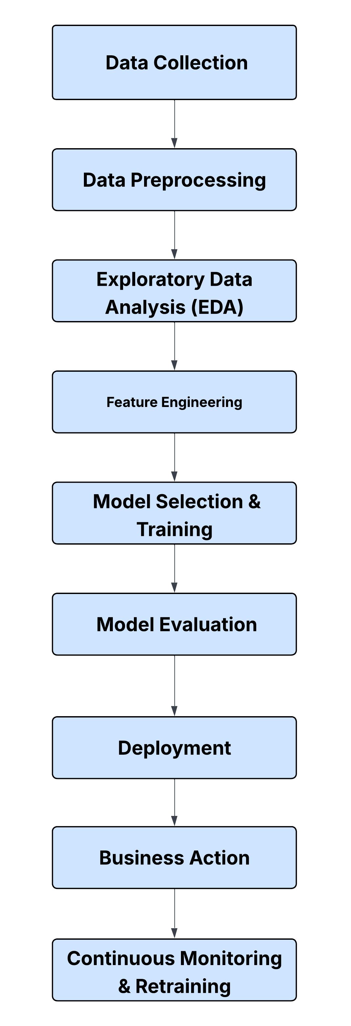

**6. Dataset Description**

* ***Dataset name and origin:*** *Telco Customer Churn dataset. Originates from Kaggle ([Specify Kaggle dataset link if available, otherwise just "Kaggle Open Dataset"]).*
* *Type of data: Structured, primarily tabular data with a mix of numerical and categorical features.*
* ***Number of records and features:*** *Approximately 7,043 records (rows), each representing a unique customer, and 21 features (columns), including the target variable.*
* ***Static or dynamic dataset:*** *Static. This dataset represents a snapshot of customer information at a specific point in time, although it likely reflects historical behavior up to that point.*
* ***Target variable:*** *Churn (Binary: "Yes" or "No"), indicating whether the customer churned (discontinued service) within the specified period. This is a supervised learning task.*
* ***Key Feature Categories:*** *The features can be broadly categorized into:*
* ***Customer Demographics:*** *Gender, SeniorCitizen, Partner, Dependents.*
* ***Account Information:*** *Tenure, Contract type, PaperlessBilling, PaymentMethod, MultipleLines.*
* ***Service Usage:*** *PhoneService, InternetService, OnlineSecurity, OnlineBackup, DeviceProtection, TechSupport, StreamingTV, StreamingMovies.*
* ***Charges:*** *MonthlyCharges, TotalCharges.*

***The dataset comprises several key categories of features:***

***1. Customer Demographics:***

* ***CustomerID:*** *Unique identifier for each customer.*
* ***Gender:*** *Male or Female.*
* ***Age:*** *Age of the customer.*
* ***Geography:*** *Region or country of residence.*
* ***Tenure:*** *Number of months the customer has been with the company.*

***2. Account and Subscription Details:***

* ***Contract Type:*** *Monthly, one-year, or two-year contracts.*
* ***Payment Method:*** *Credit card, bank transfer, electronic check, etc.*
* ***Monthly Charges:*** *Amount billed to the customer each month.*
* ***Total Charges:*** *Cumulative amount billed to the customer.*

***3. Service Usage and Preferences:***

* ***Internet Service****: DSL, Fiber optic, or None.*
* *Online Security / Online Backup: Whether the customer subscribes to security or backup services.*
* *Tech Support / Streaming TV / Streaming Movies: Usage of additional services.*

***4. Customer Engagement:***

* ***Customer Support Calls:*** *Number of support interactions (if available).*
* ***Usage Patterns:*** *Call minutes, data usage, or login frequency (depending on dataset origin).*

***5. Target Variable:***

* *Churn: A binary variable indicating whether the customer has churned (1) or remained active (0).*

**7. Data Preprocessing**

*Data preprocessing is a crucial step in any machine learning project to ensure the dataset is clean, consistent, and suitable for modeling. In the context of customer churn prediction, the preprocessing pipeline includes the following key steps:*

***1. Handling Missing Values:***

* *Missing values in features such as TotalCharges or service-related fields are identified and handled.*
* *Numerical columns with missing data are imputed using the median or mean.*
* *Categorical columns with missing entries are filled using the mode or with a placeholder value such as 'Unknown'.*

***2. Encoding Categorical Variables:***

* *Many features are categorical (e.g., Gender, InternetService, Contract, PaymentMethod).*
* *Binary variables like Gender are label encoded (e.g., Male = 1, Female = 0).*
* *Multiclass categorical features are one-hot encoded to convert them into a numerical format while avoiding ordinality.*

***3. Converting Data Types:***

* *Columns like TotalCharges may be stored as strings and must be converted to numerical types for analysis.*
* *Invalid entries (such as blank strings) are handled during this conversion process.*

***4. Feature Engineering:***

* *New features are derived to enhance the model’s performance. For example:*
* *AvgMonthlyCharge = TotalCharges / Tenure*
* *Grouping tenure into bins to reflect customer lifecycle stages (e.g., new, mid-term, long-term).*
* *Aggregated service usage counts (e.g., total number of add-on services used).*

***5. Outlier Detection and Removal:***

* *Outliers in numerical features like MonthlyCharges or TotalCharges are detected using IQR or Z-score methods.*
* *Depending on their impact, outliers are either removed or capped (winsorization).*

***6. Normalization / Standardization:***

* *Features like MonthlyCharges, TotalCharges, and Tenure are scaled to ensure uniformity.*
* *StandardScaler or MinMaxScaler is applied depending on the algorithm (e.g., SVMs and KNN benefit from scaled data).*

***7. Handling Class Imbalance:***

* *Customer churn datasets are often imbalanced, with fewer churners than non-churners.*
* *Techniques such as SMOTE (Synthetic Minority Oversampling Technique) or ADASYN are used to balance the dataset.*
* *Alternatively, class weights are adjusted in algorithms that support it (e.g., Logistic Regression, Random Forest).*

***8. Splitting the Dataset:***

* *The dataset is split into training and testing sets (e.g., 80% train, 20% test).*
* *Further division of the training set into training and validation sets may be used during model tuning.*

**8. Exploratory Data Analysis (EDA)**

*Exploratory Data Analysis is a critical step to understand the structure, patterns, and relationships within the dataset before applying machine learning models. It involves both univariate and multivariate analysis, helping to identify trends, anomalies, correlations, and insights that can guide feature selection and engineering.*

***1. Understanding Data Distribution***

* ***Target Variable Distribution (Churn):***
* *A countplot or pie chart is used to visualize the class imbalance between churned and non-churned customers.*
* *Typically, churned customers form a minority class (e.g., 26% churn vs. 74% retention).*
* *Numerical Feature Distributions:*
* *Histograms or KDE plots for features like MonthlyCharges, TotalCharges, and Tenure.*
* *Log or square root transformations may be considered for skewed variables.*

***2. Categorical Feature Analysis***

* *Bar plots and count plots are used to examine the distribution of:*
* *Gender*
* *InternetService*
* *Contract*
* *PaymentMethod*
* *These plots help detect which categories are more prone to churn.*

***3. Churn vs. Feature Comparison***

* ***Churn Rate by Category:*** *Grouped bar charts showing the proportion of churn for each category within features like Contract, OnlineSecurity, and TechSupport.*
* ***Example insight:*** *Customers with month-to-month contracts churn more than those on annual contracts.*
* *Box Plots for Numerical Features by Churn:*
* *Visual comparisons of MonthlyCharges, TotalCharges, and Tenure for churned vs. non-churned customers.*
* ***Example insight:*** *Customers with lower tenure and higher monthly charges are more likely to churn.*

***4. Correlation Analysis***

* *Correlation Matrix (Heatmap):Shows pairwise Pearson correlation coefficients between numerical variables.*
* *Helps detect multicollinearity and relationships that might be useful for modeling.*
* *Tenure and TotalCharges often show high positive correlation.*

***5. Service Combinations and Churn***

* *Create features such as the number of services a customer uses (TotalServices) and analyze their relation to churn.*
* *Plot churn rate across different service usage patterns.*

***6. Customer Segmentation***

* *Use pair plots or PCA to visually explore clusters in customer behavior.*
* *This can reveal segments that are particularly loyal or at high risk of churn.*

***7. Missing Values and Anomalies***

* *A heatmap or bar chart is used to inspect missing data.*
* *Anomalous data (like negative charges or zero tenure) is flagged for cleaning.*

**9. Feature Engineering**

*Feature engineering plays a vital role in enhancing model performance by creating informative and meaningful features from raw data. It involves transforming existing features, creating new ones, and eliminating irrelevant or redundant variables. For customer churn prediction, this process is especially important to uncover deeper insights into customer behavior and service interaction.*

***1. Derived Features***

* *AvgMonthlyCharge = TotalCharges / (Tenure + 1)*
* *Helps understand the average spend per month and accounts for division by zero.*
* *IsNewCustomer = 1 if Tenure <= 1, else 0*
* *Flags very new customers who are often more likely to churn.*
* *TotalServices = Count of optional services used (e.g., OnlineSecurity, StreamingTV, etc.)*
* *Indicates customer engagement with the company’s offerings.*
* *HasMultipleLines = Binary encoding of MultipleLines feature.*
* *Simplifies multi-category variables for easier interpretation.*

***2. Binning and Grouping***

* ***Tenure Binning:***
* *Create tenure groups such as:*
* *0–12 months → New*
* *13–24 months → Mid-term*
* *25+ months → Long-term*
* *Enables categorical analysis of customer lifecycle stages.*
* ***Charge Tiering:***
* *Group MonthlyCharges or TotalCharges into low, medium, and high tiers to highlight spending levels.*

***3. Interaction Features***

* *Combine categorical and numerical variables to capture richer patterns:*
* ***Contract * PaymentMethod:*** *Certain combinations may indicate higher churn risk.*
* ***InternetService * StreamingTV:*** *Use of entertainment services may reduce churn.*

***4. Encoding Features***

* *Label Encoding for binary variables like Gender, Partner, Dependents.*
* *One-Hot Encoding for multi-category fields like InternetService, Contract, PaymentMethod, etc.*
* *Target Encoding (optional and with care to avoid data leakage) for features that show a strong relationship with churn.*

***5. Behavioral Flags***

* *Low Engagement Flag = 1 if customer has few or no additional services.*
* *High Risk Profile = 1 if customer is new, has high monthly charges, and no security or support services.*

***6. Date-based Features (if timestamps are available)***

* *DaysSinceSignup, DaysSinceLastInteraction, etc., can be extracted to reflect recency and loyalty.*

***Impact of Feature Engineering:***

*These engineered features help improve model interpretability and predictive power. For instance, high-churn customers may often have a low TotalServices count, be on month-to-month contracts, and lack value-added services like OnlineBackup or TechSupport. Capturing these patterns through engineered features improves both model accuracy and business insight.*

**10. Model Building**

*After preprocessing the data and engineering informative features, the next step is to build and evaluate machine learning models that can accurately predict customer churn. This involves selecting appropriate algorithms, training models on the processed dataset, tuning hyperparameters, and assessing model performance using relevant metrics.*

***1. Train-Test Split***

* *The dataset is split into training and test sets (commonly 80/20 or 70/30 split).*
* *Optionally, a validation set or k-fold cross-validation is used for model selection and tuning.*

***python program:***

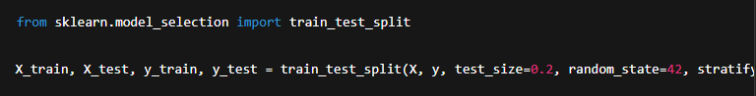

***2. Baseline Models***

* *Start with simple models to establish a baseline:*
* *Logistic Regression for interpretability and quick insights.*
* *Decision Tree Classifier for visualizing decision paths.*

***3. Advanced Models***

* ***Random Forest:*** *Handles feature interactions well and is robust to noise.*
* ***Gradient Boosting (e.g., XGBoost, LightGBM):*** *Often provides state-of-the-art performance on tabular data.*
* ***Support Vector Machines (SVM):*** *Useful in high-dimensional spaces.*
* ***K-Nearest Neighbors (KNN):*** *A non-parametric method that can capture non-linear relationships.*

***python program:***

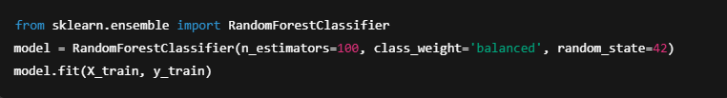

***4. Model Evaluation***

* *Evaluation metrics include:*
* *Accuracy (can be misleading with imbalanced data)*
* *Precision, Recall, F1-score (especially important for the minority churn class)*
* *ROC-AUC Score to evaluate the trade-off between true positive and false positive rates*
* *Confusion Matrix for classification breakdown*

***python program:***

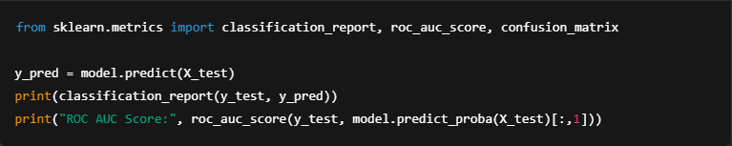

***5. Hyperparameter Tuning***

* *Use Grid Search or Random Search to optimize model performance:*

***python program:***

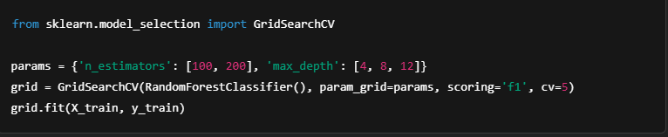

***6. Cross-Validation***

* *Perform k-fold cross-validation to assess the model's generalizability:*

***python program:***

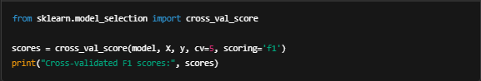

***7. Model Interpretation***

* *Use feature importance (in tree-based models) or SHAP values to understand model decisions and key churn drivers.*
* *Identify top contributing features (e.g., Contract, MonthlyCharges, TechSupport, Tenure).*

***Conclusion:***

*Multiple models are trained and evaluated to select the best-performing one. Tree-based ensemble methods like Random Forest and XGBoost generally perform well for churn prediction tasks due to their ability to capture complex feature interactions and handle imbalanced datasets. The final model can be saved and integrated into production systems for real-time or batch predictions.*

**11. Model Evaluation**

*Model evaluation is crucial for assessing how well the trained machine learning model performs on unseen data and how effectively it distinguishes between customers who will churn and those who will not. Since churn prediction often involves imbalanced classes, relying solely on accuracy can be misleading. Therefore, a combination of performance metrics is used to provide a holistic evaluation.*

***1. Confusion Matrix***

* *A confusion matrix shows the breakdown of predictions:*
* *True Positives (TP): Correctly predicted churns*
* *True Negatives (TN): Correctly predicted non-churns*
* *False Positives (FP): Non-churns incorrectly predicted as churns*
* *False Negatives (FN): Churns incorrectly predicted as non-churns*

***python program:***

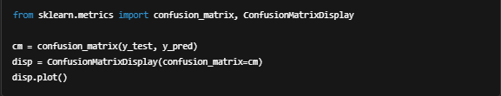

***2. Accuracy***

*Measures the overall proportion of correct predictions.*

*Not reliable with imbalanced data.*

***Formula:***

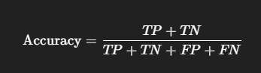

***​3. Precision, Recall, and F1-Score***

*These metrics are more informative in imbalance-sensitive tasks like churn prediction.*

* *Precision: How many predicted churns were actually churners?*

*​*

* *Recall (Sensitivity): How many actual churners were correctly identified*



* *F1-Score: Harmonic mean of precision and recall.*

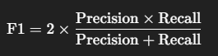*​*

***python program:***

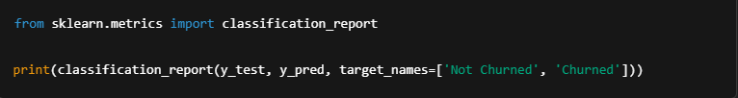

***4. ROC Curve and AUC (Area Under Curve)***

* *The ROC curve plots True Positive Rate vs. False Positive Rate.*
* *AUC closer to 1.0 indicates strong classification performance.*

***python program***

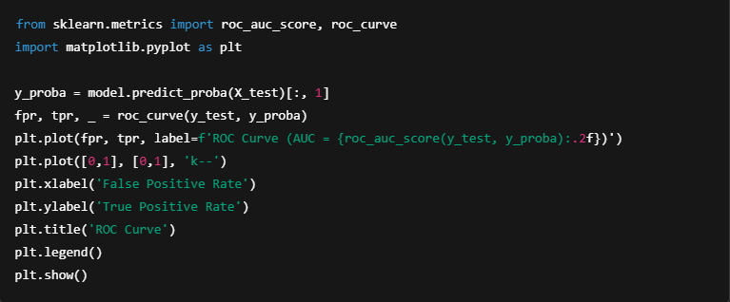

***5. Cross-Validation Scores***

* *5-fold or 10-fold cross-validation ensures model generalizability.*
* *Evaluate average F1-score or ROC-AUC across folds.*

***python program***

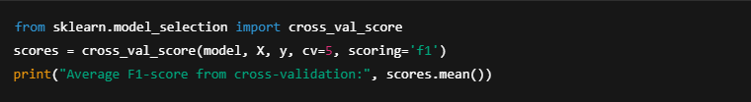

***6. Feature Importance (for Tree-Based Models)***

* *Identifies the most influential features driving predictions.*
* *Helps guide business decisions and targeted customer retention strategies.*

***python program***

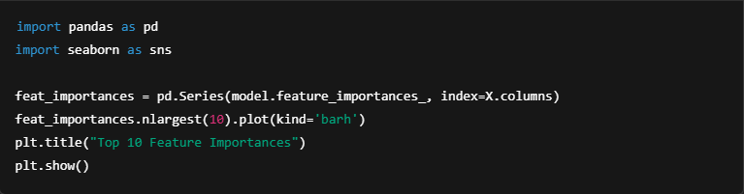

***Summary:***

* *Models are compared using F1-score and ROC-AUC as primary metrics due to class imbalance.*
* *Final model demonstrates strong recall and precision on churn prediction.*
* *Feature importance shows that variables like Contract type, MonthlyCharges, Tenure, and TechSupport are key churn drivers.*

**12. Deployment**

*Once the machine learning model has been trained and evaluated with satisfactory performance, the final step is deployment. Deployment makes the model accessible for real-time or batch predictions, allowing businesses to proactively act on churn risks. This phase involves preparing the model for use in a production environment and integrating it into the company’s systems.*

***1. Model Serialization***

*The trained model is saved using serialization tools like joblib or pickle so it can be reloaded for inference.*

***python program***

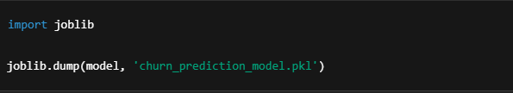

***2. Building an Inference Pipeline***

* *Create a complete pipeline that includes:*
* *Data preprocessing*
* *Feature engineering*
* *Model prediction*

***python program***

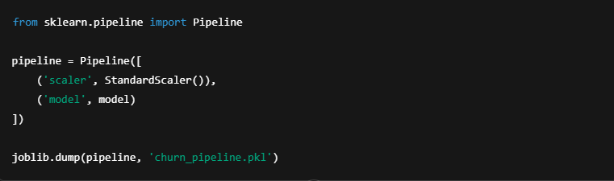

***3. Creating an API (Flask or FastAPI)***

*A RESTful API can expose the model to external systems.*

*Example using Flask:*

***python provides***

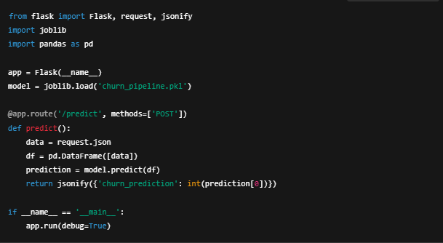

***4. Deployment Options***

* *Cloud Platforms: AWS (SageMaker), Google Cloud (Vertex AI), Azure ML.*
* *Containers: Use Docker to package the model and API, enabling scalable deployment.*

***dockerfile:***

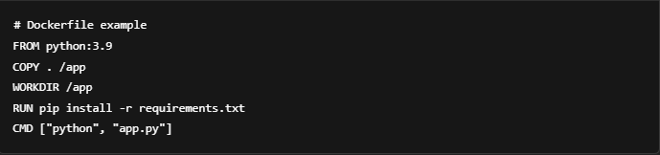

***5. Monitoring and Maintenance***

* *Track prediction accuracy and performance using monitoring tools.*
* *Re-train the model periodically with new data to keep it accurate.*
* *Set alerts for concept drift if the churn behavior changes over time.*

***Conclusion:***

*Deployment bridges the gap between modeling and real-world impact. With a deployed churn prediction model, businesses can receive near real-time alerts for high-risk customers and implement targeted retention strategies—ultimately improving customer lifetime value and reducing churn rates.*

**13. Source code**

***1. Model Training and Serialization (Model Saving)***

*First, we need to train the model and save it. If you already have a trained model, skip to step 2. If not, here's an example to train and serialize a RandomForestClassifier:*

***python program***

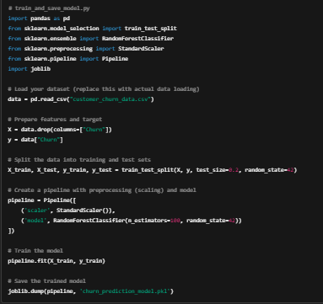

***2. Flask API for Predictions***

*Now, create the Flask API to load the trained model and provide predictions via a POST request.*

***python program***

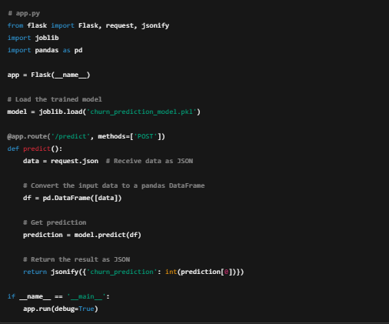

***3. Test the Flask API***

*Once the app.py file is ready, you can test it locally. Run the Flask application:*

***bash***



*The API will be running on* [*http://127.0.0.1:5000*](http://127.0.0.1:5000/)*. You can test it by sending a POST request with customer data.*

*Example input for POST request (JSON format):*

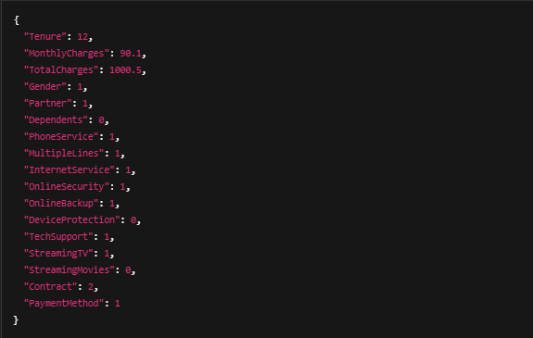

***4. Dockerize the Flask API***

*To deploy the model API in a Docker container, we need to create a Dockerfile. Below is an example:*

***dockerfile:***

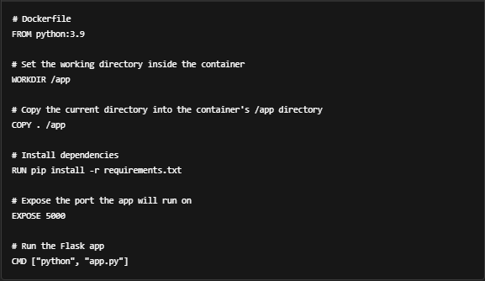

***5. Create a Requirements File***

*Make sure to include the necessary libraries in a requirements.txt file:*

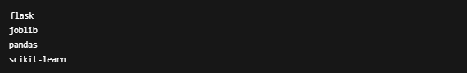

***6. Build the Docker Image***

*Now, you can build and run the Docker image to containerize the Flask app:*

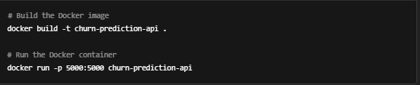

*This will start the Flask app inside the Docker container and expose it on*

*port 5000.*

***7. Test the Deployed API***

*Once the Docker container is running, you can test the prediction API by sending a POST request to* [*http://localhost:5000/predict*](http://localhost:5000/predict) *with the same JSON payload as in step 3.*

***8. Deployment on Cloud (Optional)***

*For cloud deployment, you can push the Docker image to a cloud platform (AWS, GCP, or Azure) using their container registry (e.g., Amazon Elastic Container Registry for AWS). Then, use Kubernetes or a service like AWS Elastic Beanstalk or Google App Engine to manage the container.*

***Conclusion:***

*With the above steps, you have successfully built and deployed a customer churn prediction model using Flask and Docker. This enables real-time predictions on new customer data, and the model can be integrated with other business systems, such as CRM tools, to proactively identify customers at risk of churn.*

**14. Future scope**

*The future scope of customer churn prediction projects can be expanded in several directions to enhance accuracy, user experience, and business value. Here are some potential areas to consider for further development and improvement:*

***1. Model Improvement***

* ***Deep Learning Models:***
* *Experiment with deep learning techniques like Neural Networks (e.g., feedforward neural networks, recurrent neural networks for time-series data) to capture more complex patterns.*
* *Autoencoders could be used to reduce dimensionality and extract more useful features.*
* ***Ensemble Techniques:***
* *Combine multiple models (e.g., Stacking, Voting Classifier) to improve prediction robustness.*
* *Explore Meta-Learning approaches that learn the best model combination from the data.*
* ***Model Interpretability:***
* *Use SHAP (SHapley Additive exPlanations) or LIME (Local Interpretable Model-agnostic Explanations) to provide more interpretable results, helping businesses understand why a customer is predicted to churn.*
* *Allow business users to query the model and understand what factors influenced the churn prediction.*
* ***Advanced Hyperparameter Tuning:***
* *Use Bayesian Optimization or Genetic Algorithms for a more refined search of the best hyperparameters for your models, improving overall accuracy.*

***2. Data Expansion and Feature Engineering***

* ***Additional Data Sources:***
* *Integrate data from customer interactions (e.g., Call Logs, Support Tickets, Email Interactions), which can provide deeper insights into churn behavior.*
* *Use social media sentiment analysis (via tools like Twitter API or Google Trends) to gather data on customer satisfaction and brand perception.*
* ***Temporal Features:***
* *Incorporate time-series analysis to capture how customer behavior changes over time, such as churn patterns based on seasonal trends, recent activity, or external factors (e.g., economic downturns).*
* ***Behavioral Features:***
* *Track customer engagement metrics such as usage frequency, login patterns, or product feature adoption. This can help identify at-risk customers before they churn.*
* *Use text mining techniques to analyze customer feedback from surveys or support tickets.*

***3. Real-Time Predictions and Personalization***

* ***Real-Time Churn Prediction:***
* *Deploy the churn prediction model in a real-time setting, where it can provide dynamic risk scores for customers as they interact with your service.*
* *This could be integrated into CRM systems to alert customer support teams about at-risk customers instantly.*
* ***Customer Segmentation and Personalization:***
* *Combine churn prediction with customer segmentation to create personalized retention strategies. For example, targeted marketing campaigns, loyalty programs, or custom offers for specific segments based on predicted churn likelihood.*
* *Implement personalized outreach using automated messaging tools, where a customer's churn score influences the type of engagement they receive (e.g., discounts, personalized email campaigns).*

***4. Scalability and Automation***

* ***AutoML Tools:***
* *Implement AutoML frameworks (e.g., H2O.ai, Google AutoML) to automate model selection, feature engineering, and hyperparameter tuning, making the process more efficient and scalable as data grows.*
* ***Continuous Model Training:***
* *Build a model monitoring and retraining pipeline to ensure the model adapts to new data patterns over time, reducing the risk of model drift.*
* *Integrate active learning where the model requests human feedback on uncertain predictions to improve its learning process.*

***5. Business Insights and Reporting***

* ***Churn Prediction Dashboard:***
* *Build a business intelligence dashboard (using tools like Tableau, Power BI, or Streamlit) that visualizes churn predictions, segmentation, and other key metrics.*
* *Provide decision-makers with actionable insights based on churn patterns, customer lifetime value, and retention opportunities.*
* ***Churn Attribution:***
* *Develop methods to attribute churn to specific causes (e.g., poor service quality, product dissatisfaction, pricing). This can help pinpoint areas for improvement in products or services.*

***6. Ethical and Responsible AI :***

* ***Bias Mitigation:***
* *Ensure that the churn prediction model does not introduce biases, especially related to sensitive attributes like gender, age, or ethnicity. Implement techniques like Fairness Constraints and Adversarial Debiasing.*
* ***Transparency and Explainability:***
* *As churn prediction models become more complex, it is essential to ensure they are transparent and explainable to stakeholders. Use techniques that allow business users to understand how decisions are made, especially when the consequences involve customer retention.*

***7. Expanding to Multi-Channel Customer Retention***

* ***Cross-Channel Retention Strategies:***
* *Extend the churn prediction to multiple channels, including mobile apps, social media, and email marketing. Use predictive analytics to create personalized retention strategies across these channels, optimizing customer retention efforts.*
* ***Chatbots and AI Assistants:***
* *Integrate churn prediction with chatbots or virtual assistants that automatically engage at-risk customers and provide them with retention offers, such as discounts, personalized recommendations, or exclusive content.*

***8. Industry-Specific Applications***

* ***Telecom and Subscription Services:***
* *For industries like telecommunications or streaming services, model improvements could include integrating network usage patterns or content consumption behavior to enhance churn predictions.*
* ***E-commerce and Retail:***
* *For retail businesses, predict churn based on purchase frequency, shopping cart abandonment, and product return rates. Integrate churn models with customer loyalty programs to create effective retention strategies.*

**13. Team Members and Roles**

***1. SANTHOSH KUMAR K – Project Manager***

***Responsibilities:***

* *Managed overall project planning and coordination.*
* *Defined project scope, objectives, and timelines.*
* *Monitored progress, resolved roadblocks, and ensured timely delivery.*

***Tasks:***

* *Coordinated meetings with all stakeholders and technical team.*
* *Ensured project milestones were met.*
* *Oversaw documentation and final reporting.*

***2. HARINI S– Data Engineer***

***Responsibilities:***

* *Handled data acquisition, transformation, and integration.*
* *Built data pipelines and prepared data for modeling.*

***Tasks:***

* *Collected data from various sources including customer usage logs and CRM exports.*
* *Developed ETL scripts to clean and merge raw data.*
* *Structured the dataset to ensure compatibility with machine learning frameworks.*

***3. SANTHOSH G – Data Scientist***

***Responsibilities:***

* *Led the development of the machine learning model.*
* *Performed data cleaning, analysis, and model evaluation.*

***Tasks:***

* *Conducted data preprocessing: handled missing values, encoded categorical variables, normalized features.*
* *Performed exploratory data analysis (EDA) to understand key trends and patterns in customer behavior.*
* *Engineered features like tenure group, average monthly charges, and service usage flags.*

***4. HARI GANESH B – Software Engineer (Backend)***

***Responsibilities:***

* *Developed and deployed the model into a functional backend.*
* *Integrated the model with a RESTful API.*

***Tasks:***

* *Created an API using Flask to expose the churn prediction service.*
* *Integrated the API with front-end reporting tools.*
* *Containerized the application using Docker for easy deployment.*